**CADTASK: TolAnalyst Tutorial Instructions**

The instructions can be found in SolidWorks in-built Tutorials as seen here: 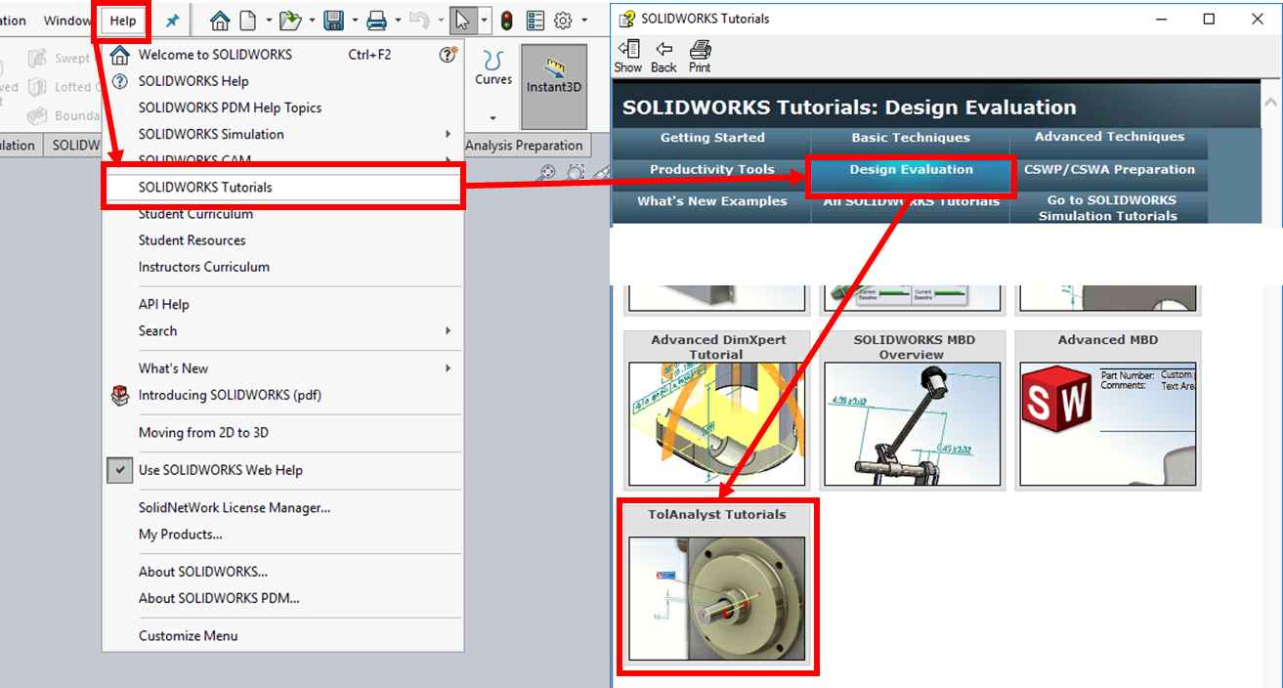

Your tutor have a quick check on the tolerance **Axle Support** in the following session.